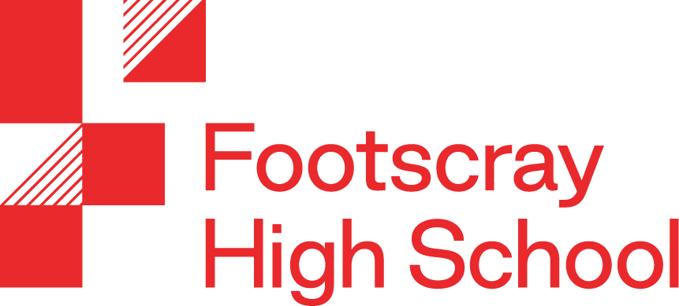

Curriculum Policy

OUR SCHOOL
Footscray High School is a new and contemporary multi-campus secondary school in Melbourne’s vibrant, geographically rich and culturally diverse inner west.
At Footscray High School we are committed to every student having access to a world class education. Inspiring young people to develop the ‘essential skills’ required for their future pathways in an inclusive and positive learning environment is our priority.
We will provide all students with a comprehensive and innovative curriculum that focuses on individual growth and addresses the skills and dispositions required for citizens of the 3rd millennium. Our vision is to draw on international research and best practice to ensure that our curriculum and programs promote choice and agility to deal with complex, unknown and rapidly changing futures.
The high-tech environment will ensure new technologies are ubiquitous in everyday teaching and learning programs. The use of technologies and media will ensure students are provided with a continuous ‘blended learning’ environment, where direct person-person relationships are supplemented by contact with other individuals, communities, materials and learning activities remote from the school in time and space but accessed online.
Footscray High School’s vision is to provide excellence in learning and teaching, achievement, innovation and self- improvement within a supportive, healthy, safe and secure environment that is inclusive of all.

OVERVIEW
Footscray High School will meet and exceed the minimum standard with:
- A whole school curriculum scheme that identifies time allocations per each of the eight learning areas.
- An outline of how the school will deliver its curriculum (based on the school derived continua).
- An explanation of how curriculum and teaching practice will be reviewed.
- A documented strategy to improve learning outcomes located within the School’s strategic plan. (an annual implementation plan will be developed in term 4 2019)

When developing the curriculum, we consider aim and value:
- A holistic approach to teaching and learning
- Setting high expectations
- Developing capacity to identify progress
- Developing an informed global citizen
- Incorporating practices that facilitate transparency in the school curriculum
- Diversity in our curriculum
- Personalised approach to teaching and learning
- Developing robust pathways to Tertiary education.
- Opportunities to enrich learning through extracurricular activities
- Engagement in the broader school community
- Providing learning opportunities to work collaboratively

CURRICULUM FRAMEWORK
The Footscray High School Curriculum Framework documents cascade through the four interrelated layers of:
- School Curriculum
- Learning areas, capabilities and cross curriculum priorities
- Unit and Lesson Sequence Planning

School
Each year the School will map out its curriculum offerings in the form of a curriculum plan. To maximise teaching and learning outcomes the School is committed to providing a sequential teaching and learning program that delivers a comprehensive, conceptually explicit and culturally inclusive curricula.
A summary of the coverage of all the Victorian Curriculum learning area standards and capabilities is represented in our whole school curriculum scheme. This scheme allows the School’s Curriculum Area Leaders to identify standards and capabilities that will be tracked across Years 7-10. This foundational document is used to inform, unit design, lesson sequence design, assessment design and reporting. Included in the curriculum scheme is the allocation of time per week for the duration of the year ensuring a balanced and inclusive curriculum is provided for a diverse student body.
Additionally the school curriculum scheme ensures that all learning areas are engaging in opportunities to explicitly develop literacy, numeracy and information technology skills.
The schools leadership/improvement team can use this curriculum scheme to identify resource needs and make informed decisions about priorities and design processes to monitor the use of the School’s resources.
A focus for development in 2020 is recognising the scope for the incorporation of integrated, interdisciplinary inquiry-based units of work. These endeavour to promote a holistic experience for learners that will culminate in a final summative assessment that can be used as a source of evidence for at least four subject reports.
The school has some unique offerings including:
- 25 places in a Select Entry Accelerated Learning (SEAL) program in Mathematics, English Humanities and Science and entrance is based on a test and interview.
- a sports program is offered within the school teaching day and provides opportunities for students to participate in a range of sports.
- a school wide literacy program.
- International student programs.

Learning areas, capabilities and cross curriculum priorities
The School has sequenced the key knowledge, skills and conceptual underpinnings to support a progression of learning. These can be accessed by all staff on the shared drive.

The Victorian Curriculum is the foundational planning document for our school derived progressions of learning (continua). These aim to ensure a common understanding of the hierarchical nature of the complexity of content knowledge, skills and the underlying concepts students are expected to demonstrate competency in, between and across year levels and provide transparency for teachers and students. These continua also allow teachers to identify students that may fall above or below the expected standard and direct staff to the explicit knowledge and skills allowing identification of students that may require targeted intervention.

The learning area continua have been documented using observable behaviour language and taxonomy verbs in line with the research of Professor Patrick Griffin and the assessment research centre (ARC) at The University of Melbourne. The refining of these learning progressions is an ongoing process with progression markers adapting as informed by cohorts of students and other determining factors; such as an increase of conceptual awareness as moderating staff members become more familiar with units of work and expected outcomes.

Unit / lesson plans
Collaboratively designed and populated units of work have been developed using Google Apps for Education and designated LMS to be implemented at Year 7 in 2020. These units are directly aligned to the learning area progressions and allow scope for differentiated teaching strategies should evidence suggest the need. Units of work are organised into sequences of learning with documented learning intentions. These sequences of learning identify for both staff and students the content, skills, concepts, literacy, numeracy and I.T demands along with explicit reference to any of the four capabilities being addressed. This online framework allows staff to collaboratively populate the site with common teaching resources and learning tasks with scope to include targeted teaching interventions.

The planning of lesson sequences is underpinned by a theoretical conceptual planner. Using this ‘structure of knowledge’ conceptual organiser as a theoretical planning document, teachers, through diagnostic assessment can identify at which level of this hierarchy students are operating at unscaffolded and prepare targeted interventions that will cater for diverse cohorts of students. For example, groupings of students may be able to group facts into ‘topic chunks’ but may not be able to apply the same information to demonstrate a conceptual understanding.

Sequences of lessons are designed to avoid framing a set of isolated facts but rather to identify the conceptual overlays. The following diagram illustrates the hierarchy of knowledge that is documented in learning sequences across our curriculum platform

CURRICULUM GUIDELINES
Footscray High School will recognise and respond to diverse student needs when developing its curriculum programs and curriculum plan. Footscray High School will comply with all DET guidelines about the length of student instruction time required in Victorian schools.

Footscray High School implements the Victorian Curriculum 7-10 which sets out what every student should learn. The curriculum is the common set of knowledge and skills required by students for life-long learning, social development and active and informed citizenship.
The design of the Victorian Curriculum F–10 is set out below:
Learning Areas
- English
- Mathematics
- Science
- Languages
- Health & Physical Education
- The Humanities
- Technologies
- The Arts
Capabilities
- Critical and Creative Thinking
- Ethical
- Intercultural
- Personal and Social
There will be a broad offering of programs to meet demand, and designed to enhance effective learning for the 21st century. The Department of Education and Training places a high priority on the teaching of Physical and Sport Education, Languages and EAL. Our school also places a high priority on the teaching of these learning areas.

Preparing young people for the transition from school into further education and careers will be a critical element in senior secondary program. Teaching and learning programs will be resourced through Program Budgets.

PROGRAM

Program Development
- Footscray High School will provide a variety of programs that will address the specific needs of students in relation to gender, special learning needs, disabilities and impairments, giftedness and students from language backgrounds other than English.
- The school will identify and cater for the different needs of particular cohorts of students when developing its curriculum plan. In developing its curriculum plan the school will provide a broad range of educational pathways to ensure improved student outcomes.
- The Victorian Curriculum (VC) will be used as a framework for curriculum development and delivery at Foundation - Year 10 in accordance with DET policy and Victorian Curriculum and Assessment Authority (VCAA) guidelines.
- The Victorian Certificate of Education (VCE) and the Victorian Certificate of Applied Learning (VCAL) will be used as a framework for curriculum development, delivery and assessment at Years 11 and 12 in accordance with VCAA guidelines.
- Footscray High School will ensure compliance and quality assurance requirements to AQTF Standards in delivering Vocational Education and Training (VET) and structured workplace learning (SWL) programs.
- The school when developing its Curriculum Plan will provide at least 25 hours student instruction per week.

Program Implementation
- The leadership/improvement team will determine the curriculum program for the following year, based on student demand and the needs of the School’s Curriculum Plan to maintain balance and a broad provision of subject choices. Input will be sought from the relevant staff in the curriculum area when determining programs for the following school year.
- To facilitate this implementation, course outlines, assessment criteria (matrices) and record keeping documentation and pro-formas will be produced that reflect the Victorian Curriculum
- The DET requirements related to the teaching of Languages, Physical and Sports Education, and New Arrivals Program / English as an Additional Language (EAL) will continue to be implemented.
- The use of Information and Communications Technologies (ICT) will be integrated across the curriculum to support the improvement of teaching and learning outcomes and adheres to DET’s School Policy & Advisory Guide ‘Using digital technologies to support teaching and learning and the school’s own endorsed policy.
- Curriculum leaders will be required to review their policy statement and prepare a comprehensive annual program budget and submit these to School Council.

Student Wellbeing and Learning
Footscray High School will embed student wellbeing in all learning experiences by aligning student welfare and curriculum policies and creating an educational environment and curriculum that is inclusive and meaningful to all students:
- providing an integrated and comprehensive curriculum approach that incorporates the personal and social issues of students into their daily learning experiences
- providing a flexible, relevant, inclusive and appropriate curriculum
- accommodating student developmental needs within the Victorian Essential Learning Standards stages of schooling

Students with Disabilities
- Footscray High School and the Department of Education and Training is committed to delivering an inclusive education system that ensures all students, including students with disabilities, have access to a quality education that meets their diverse needs.
- Footscray High School will liaise with DET to provide suitable programs and resources to support the delivery of high quality schooling for students with disabilities.

International Students
- Footscray High School and the Department of Education and Training is committed to delivering high quality education to all international students.
- Footscray High School will support students with additional English as Additional language programs to meet the students language level.
- The international Student Coordinator will work with Year level Coordinators and Subject experts to develop individual learning programs were appropriate.

Koorie Education
Footscray High School is committed to providing culturally appropriate and inclusive programs to Koorie students though:

- working in partnership with the Koorie community to develop an understanding of Koorie culture and the interpersonal relationship with the Koorie community, for example via Local Aboriginal Education Consultative Groups (LAECG)
- supporting the development of high expectations and individualised learning for Koorie students
- creating an environment that respects, recognises and celebrates cultural identity through practice and curriculum
- implementing initiatives and programs that meet student needs and in partnership with the Koorie community.

Curriculum and the Child Safe Standards
Footscray High School will utilize its health and wellbeing programs to deliver appropriate education to its students about:
- standards of behaviour for students attending the school;
- healthy and respectful relationships (including sexuality);
- resilience; and
- child abuse awareness and prevention.

Reporting of Student Achievement
Footscray High School will report student achievement to parents and guardians throughout the academic year. Progress reports, which communicate student learning habits, including effort, organisation, behaviour, and performance are distributed to all parents and guardians once a term. In line with DET guidelines, the school will report student achievement in all learning areas against the Victorian Curriculum standards twice a year using the prescribed five point scale indicating whether students are well below, below, at, above or well above the expected level. Achievement in specific learning areas is also reported through the use of specialised programs and assessment tools including Math Pathways, PAT R and PAT Maths, NAPLAN, and VCE achievement data.
The school is also introducing the use of continuous feedback to students, parents and guardians in 2020 through a new Learning Management System. Teachers would report feedback on common tasks that assess student progress through the Victorian Curriculum levels in each strand and sub-stand of learning areas, including the general capabilities. This initiative will be introduced at year 7 only in 2020.

Reporting Achievement for International Students.
Footscray High School ( Interim Name) will communicate academic achievement, learning behaviours and satisfactory completion of outcomes to parents of international students through formal reports, written in English, accompanied by a summary of semester reports in the language of the parent’s and guardian’s. Information related to wellbeing will be communicated to parents and guardians on a one to one basis, by phone or electronic means.

Reporting achievement from external providers (VET)
Currently, our Auspice agreement sets out that Footscray High School subject teachers report student achievement in VET subjects as per the school based reporting process outlined above. Teachers report on the competencies of each subject, indicating Satisfactorily Completed (S), Not Satisfactorily Completed (N), or Not Yet Completed (NYC). The Auspice will also provide a report at the end of the year in the form of Statement of Attainment. This lists the units the student received competency for. At the end of the second year they will send out the certificate listing the units completed or a Statement of Attainment if the student has not yet passed all units.

Curriculum and Teaching Evaluation & Review
Footscray High School has a formal process for reviewing curriculum and teaching practice. Student outcome data, including NAPLAN and VCE Achievement data, Teacher judgements against the Victorian Curriculum standards, and the Attitudes to School Survey is used to identify areas of strength and weaknesses in the curriculum program and in teacher practices in relation to the school’s long term and annual targets as set out in the Strategic Plan and Annual Implementation Plan (AIP). Identified areas of strength are celebrated and used to drive continuous improvement, and areas in need of improvement are prioritised for further investigation. A four step process is used to engage the school community in this evaluation process as outlined below.
Who | How | When
- 1. The Executive Leadership Team - Principals and Assistant Principals | Student achievement data is analyzed and compared to school targets to identify areas of strength and areas in need of improvement. The team uses tools such as ‘Traffic lights’, with the colors denoting targets achieved, in progress and not achieved, and ‘Plus, Minus, Interesting’ (PMI). | Analysis performed upon the release of data sets.  - NAPLAN - Term 3  - ATOSS - Term 3  - VCE Data - Term 4  - Victorian Curriculum Judgements - End of Term 2 and 4
2. Middle Leadership Team - Leading Teachers and Coordinators | Middle Leaders analyze student achievement data in with their relevant teams Ie. Curriculum Area Leaders, Student Management, Wellbeing, and Engagement Leaders. | Analysis performed upon the release of data sets.  - NAPLAN - Term 3  - ATOSS - Term 3  - VCE Data - Term 4  - Victorian Curriculum Judgements - End of Term 2 and 4
3. Teachers | Leading teachers and coordinators lead the analysis of student achievement data with teams of teachers. Ie. Learning Area Faculties and Professional Learning Teams. | Analysis performed upon the release of data sets.  - NAPLAN - Term 3  - ATOSS - Term 3  - VCE Data - Term 4  - Victorian Curriculum Judgements - End of Term 2 and 4
4. The School Community | Student achievement data and school analyses are reported to the school community through the School Council and Annual General Meeting. | Once, in the annual report

Footscray High School also has professional learning teams (PLT) that use external and internal student achievement data to monitor and review the curriculum plan, teaching and learning, and assessment strategies. These teams use a process of moderation of common assessment tasks to identify areas of strengths and areas in need of improvement in year level and class level cohorts of students. Teams unpack this data to identify teaching practices that are positively impacting on student achievement and use this as the basis to drive improvement in teacher practice. Professional Learning teams engage in this work for one hour each week. A common PLT Cyle and templates are used.
Footscray High School has developed a coaching program aimed at reviewing and driving continuous improvement of the curriculum and teacher practice. Individual teachers engage coaches to support them in monitoring and improving aspects of their practice through a process of goal setting, classroom observation, and professional dialogue based on the ‘GROWTH’ coaching model. Footscray High School will expand this program over the next 3 years. The school will also trial the use of ‘learning walks’ to monitor and evaluate teacher practice in 2020.
The school’s online guaranteed curriculum is audited bi-annually by the Head of Curriculum, ensuring alignment with the Victorian Curriculum Achievement Standards (including the general capabilities and cross-curriculum priorities) and current VCE requirements, the use of common assessment tasks and assessment rubrics to inform teacher judgements, and the sequential delivery of content and skills in each Learning Area.

Overview
Our school will be following the Department’s Framework for Improving Student Outcomes (FISO).
The FISO is made up of three elements:
- the Improvement Cycle
- the Improvement Model, including six high-impact Improvement Initiatives, and
- the Improvement Measures.
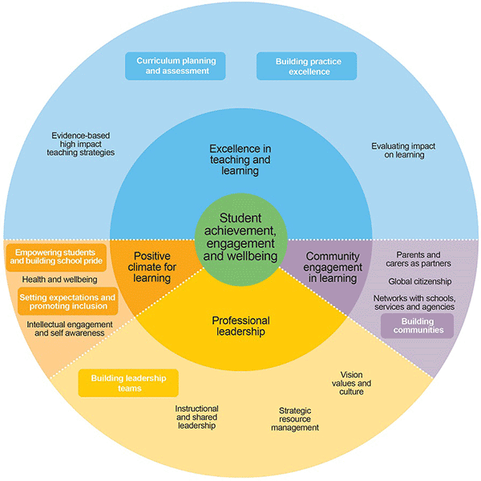

FISO Improvement Cycle
The Improvement Cycle uses an evidence-based model that helps schools to implement a more effective continuous Improvement Cycle. Our School uses the Improvement Cycle to: self-evaluate, review and diagnose areas that require attention, plan for improvement and report to our community on our activities, outcomes and plan for improvement.

FISO Improvement initiatives
The six Improvement Initiatives are:
- Building practice excellence
- Curriculum planning and assessment
- Building leadership teams
- Empowering students and building school pride
- Setting expectations and promoting inclusion
- Building communities.
As a new school our 2020 – 2021 Annual Implementation Plan (AIP) will focus on:
- To be determined in term 4 2019

Endorsement of our school’s first AIP by the principal, Senior Education Improvement Leader (SEIL) and School Council President will be obtained within the first term of the school’s operation.

LINKS AND APPENDICES (including processes related to this policy)

APPENDIX A
Curriculum Plan - Time Allocations - Years 7 - 10

Footscray High School runs a 2 week time table. The breakdown of minutes per fortnight allocated to each subject is as follows

 | English | Humanities | Languages | The Arts | Health and PE | Sport / Leadership | Science | Maths | STEAM | Technology - Digi and Food
Year 7 | 500 | 350 | 300 | 337.5 | 250 | 100 | 300 | 450 | 300 | 112.5
Year 8 | 500 | 350 | 300 | 337.5 | 250 | 100 | 300 | 450 | 300 | 112.5
Year 9 | 450 | 350 | 300  elective | 150  elective | 300 | 200  elective | 350 | 450 | 600 | 150  elective
Year 10 | 500 | 500  elective | 500  elective | 500  elective | 500 | 500  elective | 500  elective | 500 |  | 500  elective

APPENDIX B
Daily timetable structure - 50 minute periods

8.50 - 9.00 | Homegroup - 8
9.00 - 9.50 | Period 1
9.50 - 10.40 | Period 2
10.40 - 11.00 | Recess
11.00 - 11.50 | Period 3
11.50 - 12.40 | Period 4
12.40 - 1.30 | Lunch
1.30 - 2.20 | Period 5
2.20 - 3.10 | Period 6

Links to DET School Policy & Advisory Guide:

- Curriculum
- Using Digital Technologies to Support Learning and Teaching
- Student Wellbeing and Learning
- Students with Disabilities
- Koorie Education

- EVALUATION

This policy will be reviewed annually or more often if necessary due to changes in regulations or circumstances.

